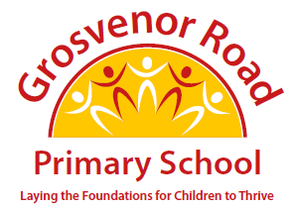

GROSVENOR ROAD PRIMARY SCHOOL
SCHOOL COUNCIL
 |  | Phone  Web | 0161 921 1200  www.grosvenorroadprimary.org
Thursday, 30 July 2026

Dear Parents and Carers,

Hello from the new school council!

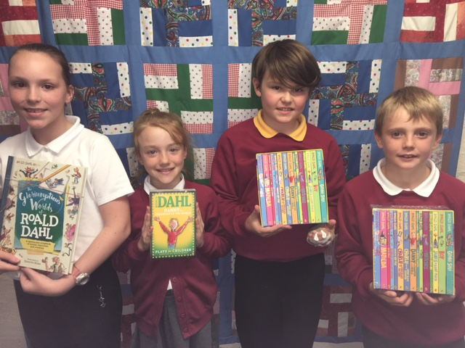
As part of the celebrations of Roald Dahl this week we are going to do a raffle.

The prizes:
- a box set of 15 Roald Dahl books (worth £98.85)
- a collection of Roald Dahl plays (worth £39.95)
- The ‘Glorumtious World of Roald Dahl’ (Our favourite? Worth £16.99)
- 15 individual story books

Tickets cost £1 a strip and can be bought between the 10th and the 17thof October. Year 5 and 6 children can buy the tickets at Registration time from their school councillors. Children in other year groups can fill in the slip below.

We want to use the money we raise to buy some Roald Dahl and other stories for outdoor libraries that we can use at playtimes.

Yours sincerely

Amelia and Nathan (School Council Chairpersons)
Grace and Jake (School Council Secretaries)
_______________________________________________________________________
School Council Raffle

Name of child ____________________________ Class __________

Number of tickets at £1 each ___________________________

Total included £ ______________

